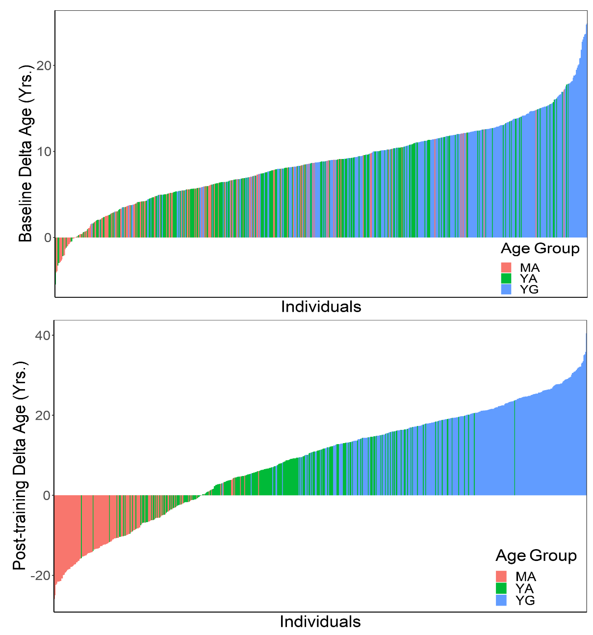
Figure S1. Waterfall plot showing individual delta age (delta age = proteomic predicted age - chronological age) at baseline and after 20 weeks of exercise training. Abbreviation: YG-Young Group (Age ≤ 29 yrs), YA-Young Adults (29 < Age ≤ 49), MA-Middle Aged (Age > 49 yrs).

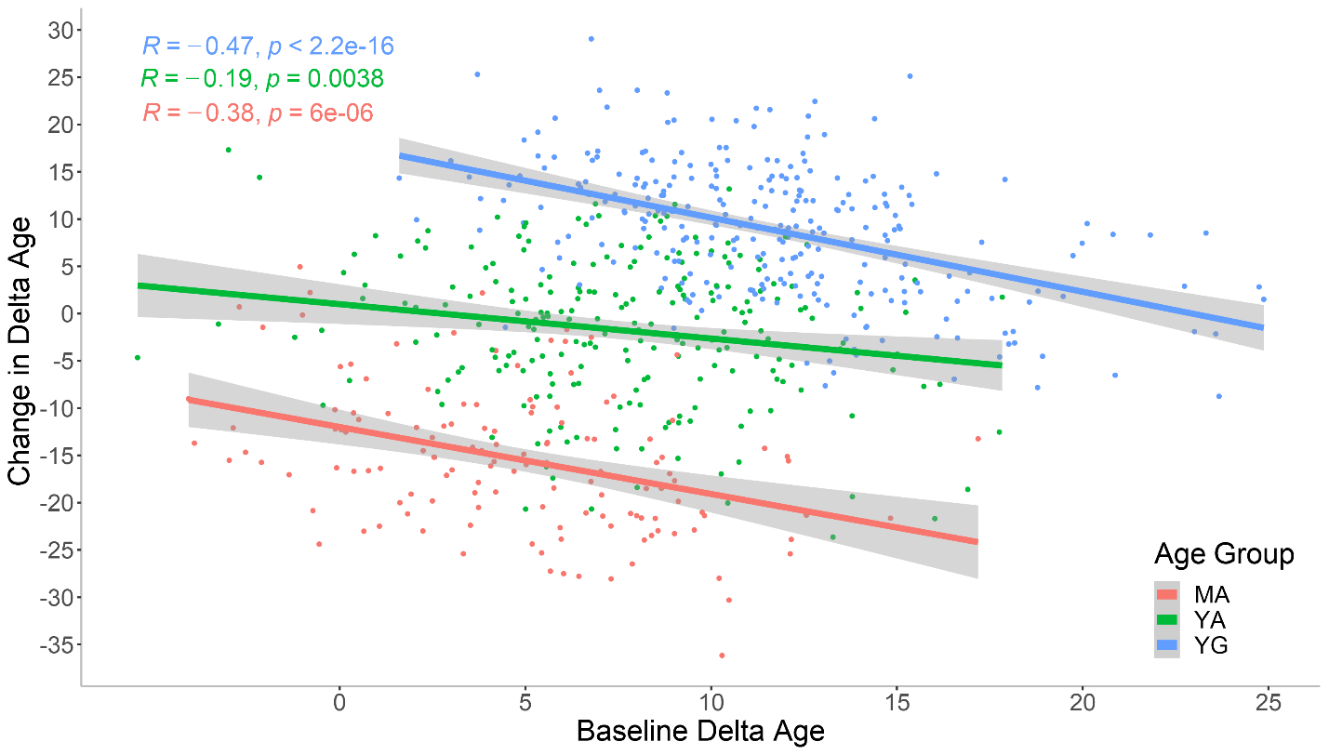
Figure S2. Scatter plot of delta age (delta age = proteomic predicted age - chronological age) at baseline vs change in delta age with exercise training in three age groups. The change in delta age is defined as the difference between post-training delta age and baseline delta age. Abbreviation: YG-Young Group (Age ≤ 29 yrs), YA-Young Adults (29 < Age ≤ 49), MA-Middle Aged (Age > 49 yrs).

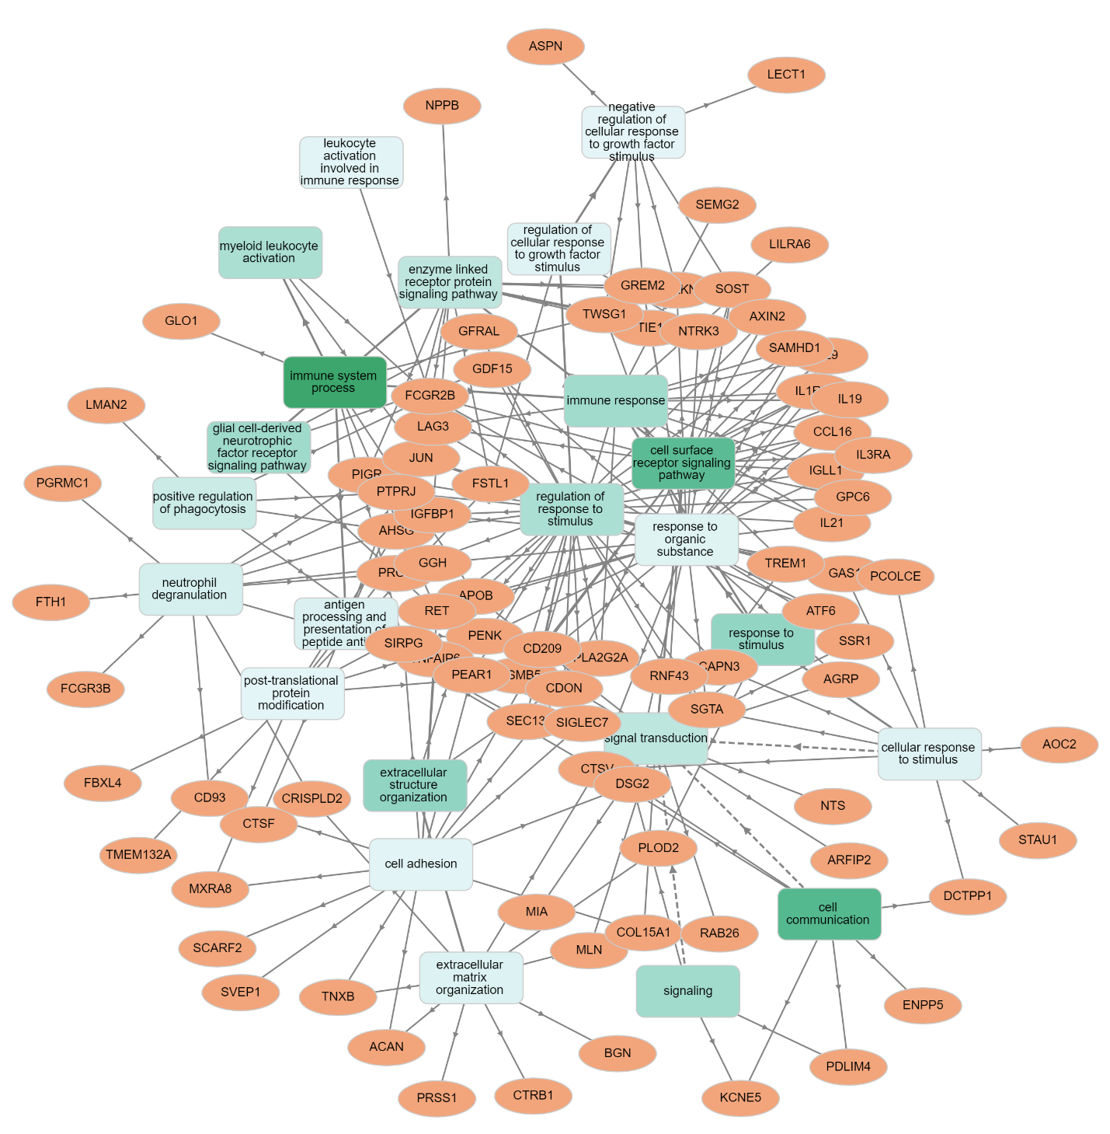

Figure S3. GOnet biological functional analysis of 105 proteins that significantly changed with training in the total sample (p<0.0001).

